**Lesson Notes**

1. What is the main purpose of an Operating System?

* Simpler / More efficient application programs
* Consistent user experience
* Allow multiple applications running at same time

1. What is the difference between Operating System Software and Use Application Software?

* Hardware independence
* User interface
* Resource allocation

1. What is the difference between Operating System Software and Computer Hardware?
2. What are the main parts of an Operating System?

* Graphical user interface
* System calls
* Device drivers
* I/O Manager
* Memory manager
* Process manager
* Security monitor
* Update manager

1. What are some popular operating systems?

* Windows OS
* Mac OS
* Linux / Unix
* Android / Chrome
* iOS
* z/OS

**Reference Diagram**

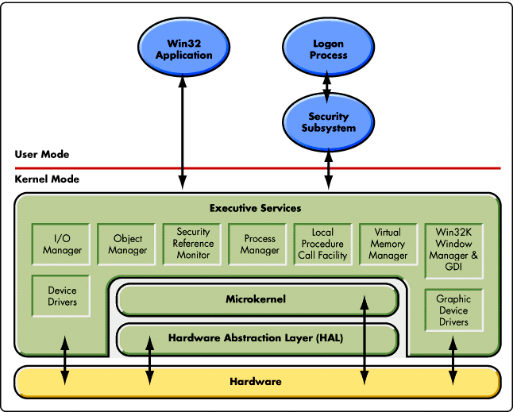

<~ windows manager

Device driver ~>

**Student Questions**

1. What is a device driver?
   1. Provide a brief summary – A computing program that that operates or controls a particular type of device that is attached to a computer.
   2. List some devices that require a device driver. – printers, CD-ROM readers, network or sound cards, computer mice or hard disks.
   3. Provide a label on the reference diagram for the location of a device driver for your graphics card. -
   4. Provide a label on the reference diagram for the location of a device driver for a locally attached printer.
2. What is a DLL?
   1. Provide a brief summary – A dynamic link library
   2. Explain how DLLs are related to user application programs – it is Microsoft version of a shared library concept in the Microsoft windows and OS/2 operating systems.
   3. Provide a label on the reference diagram for the location of a DLL – different directories
3. What is a windows manager?
   1. Provide a brief summary – A system software that controls the placement and appearance of windows within a windowing system in a graphical user interface.
   2. Explain how a windows manager is related to user application programs – it helps organize the desktop environment.
   3. Provide a label on the reference diagram for the location of a DLL -
4. What is the windows task manager?
   1. Provide a brief summary – task manager, system monitor, and startup manager included with the Microsoft systems.
   2. List and explain four (4) types of system information provided by the task manager -
   3. Provide a label on the reference diagram for the operating system components related to each type of information.